**Research Study Seeks CTE Apprenticeship Graduates**

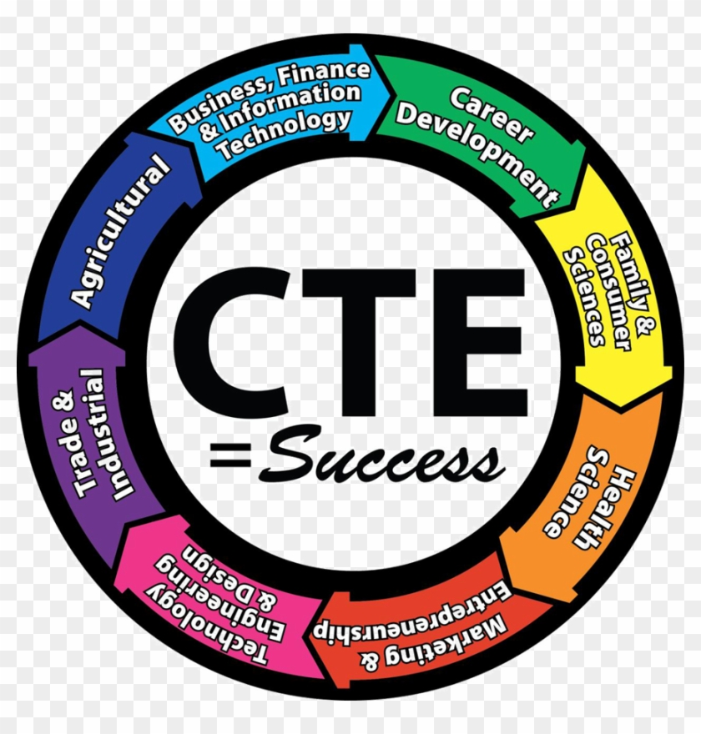

There is a new study exploring high school graduates’ perspectives of their CTE apprenticeship learning experiences. This study could help CTE educators, policy makers, and employers better understand how to support CTE apprenticeship students. You are invited to describe your perspective of your CTE apprenticeship learning experiences.

About the study:

* You will be invited to share your perceptions of your high school CTE apprenticeship learning experiences
* One 45-60 minute interview that will be audio recorded (no videorecording)
* You will receive a $10 Visa gift card as a thank you
* To protect your privacy, the published study will not share any names or details that identify you

Volunteers must meet these requirements:

* CTE apprenticeship graduate
* CTE apprenticeship graduate from 2019 – 2023
* Be at least 18 years old

This interview is part of the doctoral study for Cheryline Hewitt, a Ph.D. student at Walden University. Interviews will take place during September and October.

Please message cheryline.hewitt@waldenu.edu privately to let them know of your interest.